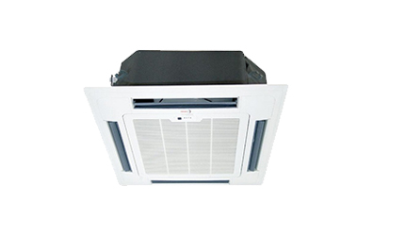

**Cassette Air Conditioner**

* Normal and inverter scroll compressor fitted cassettes available
* Capacity -1.5, 2, 3, 4 TR Available
* Meant for small confined areas like showrooms

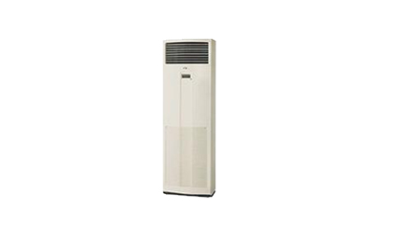

**Floor Standing Verticool Units**

* Available in capacity of 2,5 TR,3.5 TR 4.5TR .d
* Meant for small Confined areas like residences, Restaurants etc..

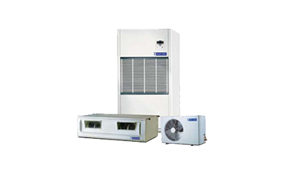

**Ducted and Floor standing Packaged units**

* Normal & Inverter scroll compressor fitted units
* Available capacity of 3, 5.5, 8.5, 11, 12 & 17TR
* Can cater any area abov 400 Sq Ft
* Inverter units can save 20-25 % of your electricity bill

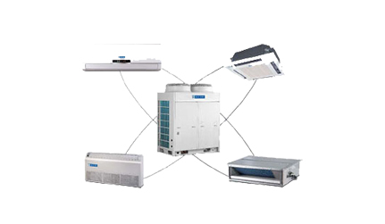

**Full Inverter VRF Systems**

* Varied indoor units can be choosen to suit the interior requirements
* All indoor units can be connected to one stroke multiple outdoor units
* Very efficient in Part load applications
* Saves 25-30% in Electricity Bills when compared to conventional A/c units.
* Varied intelligent control options available.

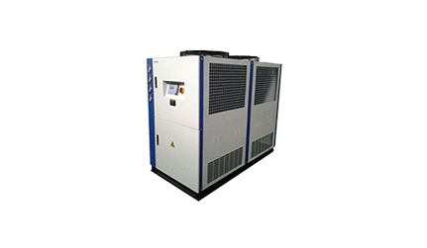

**Chiller units**

* Highly Energy Efficient
* Meant for large floor areas
* Effective in Part Load applications
* Widely used corporate ,commercial Buildings and Industrial applications



**Full Inverter VRF Systems**

* Varied indoor units can be choosen to suit the interior requirements
* All indoor units can be connected to one stroke multiple outdoor units
* Very efficient in Part load applications
* Saves 25-30% in Electricity Bills when compared to conventional A/c units.
* Varied intelligent control options available.



**Ducted and Floor standing Packaged units**

* Normal & Inverter scroll compressor fitted units
* Available capacity of 3, 5.5, 8.5, 11, 12 & 17TR
* Can cater any area abov 400 Sq Ft
* Inverter units can save 20-25 % of your electricity bill



**Floor Standing Verticool Units**

* Available in capacity of 2,5 TR,3.5 TR 4.5TR .d
* Meant for small Confined areas like residences, Restaurants etc..



**Cassette Air Conditioner**

* Normal and inverter scroll compressor fitted cassettes available
* Capacity -1.5, 2, 3, 4 TR Available
* Meant for small confined areas like showrooms

Training\

HVAC Engineering is a highly booming industry with huge demand oriented career in it. HVAC technicians focus on maintaining and repairing the systems in a private or commercial setting. Our Training will be a comprehensive study of all the basics of HVAC. These are job oriented courses to join the Industry as a Trained Professional to handle any project independently from day one. The training programme aims to harness your skills and enhance your chances for a successful career within the HVAC industry.

We are providing opportunity to the fresher’s who are interested in the HVAC industry. We are selecting the following candidates for providing training.

1. Engineering (Mech, EEE ,ECE)
2. Diploma (Mech, EEE ,ECE)

Selection Procedure is done by written examination. On Selection the training will be provided with stipend .With regular review on their performances these Trainee Engineers will be given the opportunity to work with our organisation GVJ Aircon Projects &Services .

#### After Sales Service

<="" figure="" style="box-sizing: border-box; border: 0px; vertical-align: middle; width: 201.25px; margin: 30px auto; transition: all 0.4s linear;">

<="" figure="" style="box-sizing: border-box; border: 0px; vertical-align: middle; width: 201.25px; margin: 30px auto; transition: all 0.4s linear;">

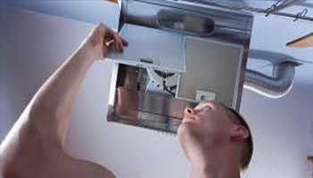<="" figure="" style="box-sizing: border-box; border: 0px; vertical-align: middle; width: 201.25px; margin: 30px auto; transition: all 0.4s linear;">

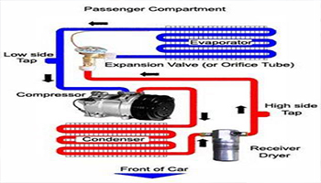<="" figure="" style="box-sizing: border-box; border: 0px; vertical-align: middle; width: 201.25px; margin: 30px auto; transition: all 0.4s linear;">

We believe in proper engineering design and quality installation and regular maintenance which enhances the life of machine and reduces power consumption. Thus after sales service is an important accept which we take care as explained below.

### ****Our team****

We have highly skilled and well trained service engineers, technicians with necessary tools & tackles to meet our customer service requirements. We adhere to quality service process and safety norms.

### ****Service Packages****

1. **Comprehensive AMC**
2. **Only Labour Contract**
3. **Revamp stroke, Re -installation of A/c Systems.**
4. **Provide solutions with energy efficient specialty service products**
5. **Duct Cleaning and Air Balancing**

By Cleaning the duct in your carpet area and balancing the airflow with the help of hood and increasing the airflow in the duct, it improves your indoor air quality.

1. **Indoor Air Quality Audit**

Provides solution by finding the Air Quality

1. **Energy Saving Product**

This Product Annually Saves Energy by 15% or more in air cooled condensers.

1. **Auto tube cleaning Systems**

Keeps the condenser tubes clean, thereby enhancing the energy of the plant. Increases cooling capacity of HVAC Chillers , Improves condenser tube life and improves chiller compressor life. Results in 10-25% energy saving in HVAC Chillers.

1. **Water Management services**

With the increasing demand of high performance green technology, BacComber not only provides more effective and efficient water treatment solutions but also long term eco friendly protection to your system.

1. **UVC Emitters**

UVC Systems a re designed to rapidly clean the cooling coil surfaces and to subsequently penetrate the gaps between the coil fins and clean wityh in the cils,thus improving the energy efficiency.

1. **Eco Savers**

Providing and Intelligent Retro fit to the existing AC , Ecosaver’s sensor driven software algorithms are designed to detect thermodynamic saturation and optimize the compressor operation accordingly. It is designed specifically for Split AC’s.

1. **Variable Frequency Drive**

We have all types of VFDs for AHUs, Pumps and Cooling Towers from all brands like Danfoss, Abb, Siemens etc.

### ****Our Testimony****

We have more than 450 satisfied customers who have trusted us and we provide world class customer experience to our valuable customers.

# Our Projects

Travel into our world of services! We are sure to impress you!

[[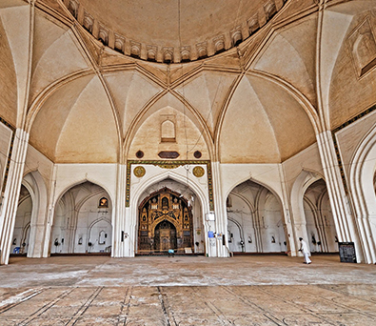](javascript:;)PRAYER HALL](javascript:;)

**[[http://www.gvjaircon.com/images/Prayer%20Halls.PNG](javascript:;)Prayer Hall](javascript:;)**

* **[Harvest Church](javascript:;)**
* **[CSI Holy Reedemer Church](javascript:;)**
* **[AG Church](javascript:;)**
* **[Army Of Jesus Church](javascript:;)**
* **[Apostolic Christian Fellowship](javascript:;)**
* **[Sheikinath Assembly](javascript:;)**
* **[Annanagar Islamic Center](javascript:;)**
* **[Jaamji A Masjid](javascript:;)**
* **[ECI St Peter's Church](javascript:;)**

[[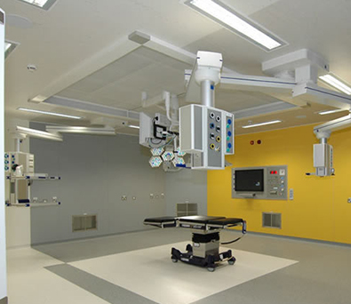](javascript:;)HOSPITAL](javascript:;)

**[[http://www.gvjaircon.com/images/Hospital.PNG](javascript:;)Hospital](javascript:;)**

* **[SRM Institute Of Medical Sciences](javascript:;)**
* **[Sri Mankula Vinyagar Medical College & Hospitals](javascript:;)**
* **[Annapoorna Medical College](javascript:;)**
* **[B M Hospitals](javascript:;)**
* **[Vijaya Diagnostic Centre](javascript:;)**
* **[Jananam Hospitals](javascript:;)**
* **[Sugam Hospitals](javascript:;)**
* **[Balaji Hospitals](javascript:;)**
* **[Motherhood Hospitals](javascript:;)**

[[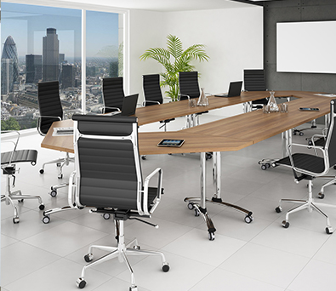](javascript:;)OFFICES](javascript:;)

**[[http://www.gvjaircon.com/images/Office.PNG](javascript:;)Offices](javascript:;)**

* **[Tamarai Tech Park](javascript:;)**
* **[P N Writer & Co](javascript:;)**
* **[Comodo](javascript:;)**
* **[Technology Frontier](javascript:;)**
* **[Zalaris](javascript:;)**
* **[Sungard Availability Services](javascript:;)**
* **[M Sys Technologies](javascript:;)**
* **[Zifo Technologies](javascript:;)**
* **[Cadbury India](javascript:;)**

[[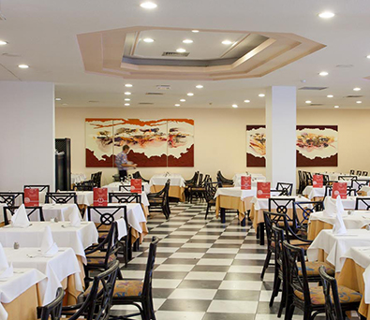](javascript:;)HOTELS](javascript:;)

**[[http://www.gvjaircon.com/images/Hotels.PNG](javascript:;)Hotels](javascript:;)**

* **[Hotel Pratap Plaza](javascript:;)**
* **[Hotel Ganesh Bhavan](javascript:;)**
* **[Hotel Mian Land China](javascript:;)**
* **[ITC Hotels](javascript:;)**
* **[Hotel Sangeetha](javascript:;)**
* **[Madras Boat Club](javascript:;)**
* **[D R Utthama Hotels](javascript:;)**
* **[Military Officers Bar](javascript:;)**

[[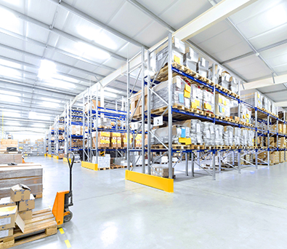](javascript:;)INDUSTRIAL](javascript:;)

**[[http://www.gvjaircon.com/images/Industrial.PNG](javascript:;)Industrial](javascript:;)**

* **[Hyundai Motors](javascript:;)**
* **[Ashok Leyland](javascript:;)**
* **[Henkel Terrson](javascript:;)**
* **[TVS Sundaram Fasteners](javascript:;)**
* **[Dover India](javascript:;)**
* **[Apache Foot Wear](javascript:;)**
* **[Savera Kothari](javascript:;)**
* **[ECGC](javascript:;)**
* **[Mico Plast Industries](javascript:;)**

[[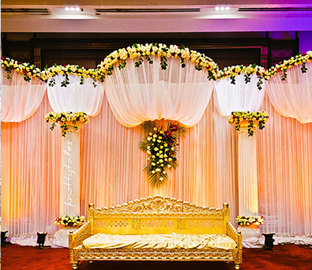](javascript:;)WEDDING HALLS](javascript:;)

**[[http://www.gvjaircon.com/images/Wedding%20Halls.png](javascript:;)Wedding Halls](javascript:;)**

* **[TSS Nadar Marriage Hall](javascript:;)**
* **[TKP Marriage Hall](javascript:;)**
* **[M R Mandram](javascript:;)**
* **[Rema Shree Mahal](javascript:;)**
* **[Manickkam Grand](javascript:;)**
* **[Mohan Towers](javascript:;)**
* **[Perunthalaivar Kamarajar Kalyana Mahal](javascript:;)**
* **[Brindavan Mahal](javascript:;)**
* **[Shree Lahshmi Narayana Mahal](javascript:;)**

[[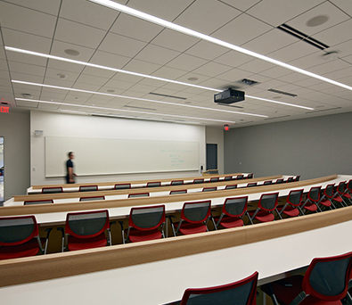](javascript:;)EDUCATIONAL](javascript:;)

**[[http://www.gvjaircon.com/images/Institution.png](javascript:;)Educational](javascript:;)**

* **[SRM Institite Of Medical Sciences](javascript:;)**
* **[Gurukul Luthern Theological College](javascript:;)**
* **[Annapoorna Medical College](javascript:;)**
* **[We Shine Academy](javascript:;)**
* **[Maharishi International Residential School](javascript:;)**
* **[JaiGopal Garodia Higher Secondary School](javascript:;)**
* **[Sri Manakula Vinayakar Medical College](javascript:;)**

[[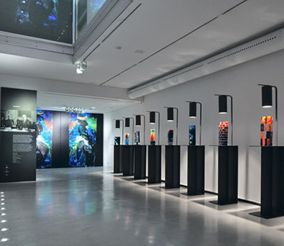](javascript:;)SHOWROOMS](javascript:;)

**[[http://www.gvjaircon.com/images/Showrooms.png](javascript:;)Showrooms](javascript:;)**

* **[Deenshah Textile Showrooms](javascript:;)**
* **[Kamadhenu Jewellers](javascript:;)**
* **[Tharagai Readymades](javascript:;)**
* **[Titan](javascript:;)**
* **[Maruti Nexa](javascript:;)**
* **[Fashion Park](javascript:;)**
* **[P R Jewellery](javascript:;)**
* **[Sree Leathers](javascript:;)**
* **[Rajmandhir Jewellers](javascript:;)**

[[](javascript:;)SUPERMARKET](javascript:;)

**[[http://www.gvjaircon.com/images/Supermarket.png](javascript:;)Supermarket](javascript:;)**

* **[Kamadhenu Supermarket](javascript:;)**
* **[APR Supermarket](javascript:;)**
* **[New Jaya Supermarket](javascript:;)**
* **[Rajam Supemarket](javascript:;)**
* **[Ayyanar Supermarket](javascript:;)**
* **[RMK Supermarket](javascript:;)**
* **[Airforce Cantten](javascript:;)**
* **[Orange Supermarket](javascript:;)**
* **[Golden Supermarket](javascript:;)**

# Our Clients

They trusted their brand with us! Why not you?

[](http://www.gvjaircon.com/)

[](http://www.gvjaircon.com/)

[](http://www.gvjaircon.com/)

[](http://www.gvjaircon.com/)

[](http://www.gvjaircon.com/)

[](http://www.gvjaircon.com/)

[](http://www.gvjaircon.com/)

[](http://www.gvjaircon.com/)